17. Solo
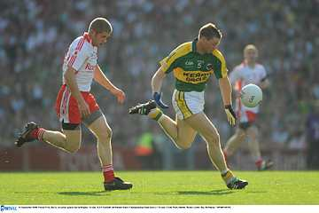

- Introduce
- Demonstrate
- Execute
- Attend

Release ball into the hand on kicking side

The Solo in Gaelic Football is a technique used to play the ball in order to keep possession without fouling. It is used to carry possession to a better position or to evade an opponent. A solo run may incorporate a sequence of alternating bounces and toe taps, or just toe taps.

Step forward,
Drop the ball on to the foot

Look out for:
- Using the opposite hand to drop the ball
- Throwing the ball
- Not using a straight leg
- Soloing too high

When ball impacts on foot, flick toes up

Extend arms to catch the ball
Pg. 67-72 FFD

Solo

Practice the Technique


Stationary Toe Tap
Players Solo the ball on the spot.

Toe Tap, Turn and Pass
Players Solo out around the cone, turns and fist passes to the next player
Crazy Solo
Players Solo in an anti-clockwise direction around the first and centre marker each time

Develop the Skill


Toe-Tap Tag
One player Solos around the grid and attempts to tag the other players
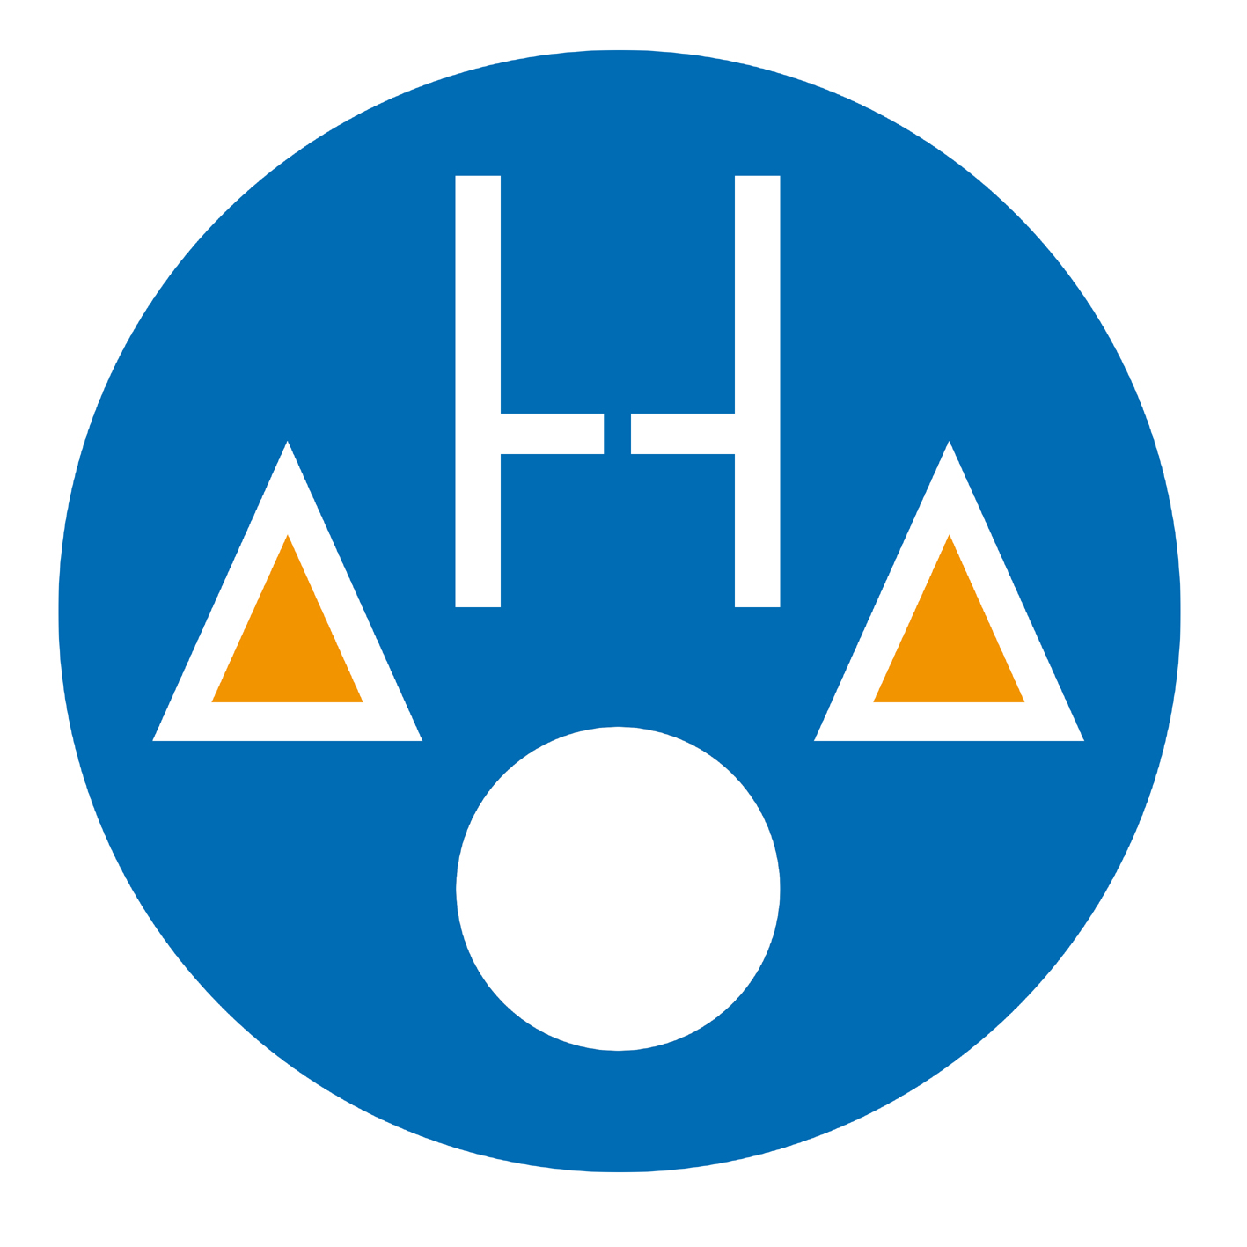
Skill Point Invasion Game
One team Punt Kicks to the other team, who then Solos and hand passes the ball up the field and through the goals to score



